Update
CRUELTY TO NONLIVESTOCK ANIMALS
SZPD-2025-40156
Schertz, TX (7/28/2025) – We have obtained an arrest warrant for Maria Maxcimiana Soliz, 61, and Ricardo Antonio Guajardo, 56, both from Schertz, TX. Ms. Maxcimiana and Mr. Guajardo both were charged with Cruelty to Non-Livestock Animals (Class A Misdemeanor) and bond will be set upon their arrest. We wish to thank the Bexar County District Attorney’s office for their assistance in our investigation of this offense. Schertz PD is presently working to locate and secure the apprehension of both suspects.
Our previous UPDATE from 7/28/2025 has produced an overwhelming response and outpouring of support from citizens throughout the area. We have received an abundance of donations for certain items and in need of the followering items:

- Cat food dishes
- Flea and Tick medication (cats and small dogs)
- Newspapers
- Unscented baby wipes
- Plastic envelopes (5x7)
- Spray bottles
- Cardboard boxes for litter boxes
- Kitten bottle nipples

If you still have a desire to donate other items, in particular food, please consider doing so through an Animal Control Services department in a local jurisdiction. We want to say THANK YOU to all of those who have made such a positive impact in dealing with this shocking incident. All donations can be dropped off at the Schertz Animal Shelter, located at 800 Community Circle. If you have any questions regarding donations, please call our Animal Services at 210-619-1550.
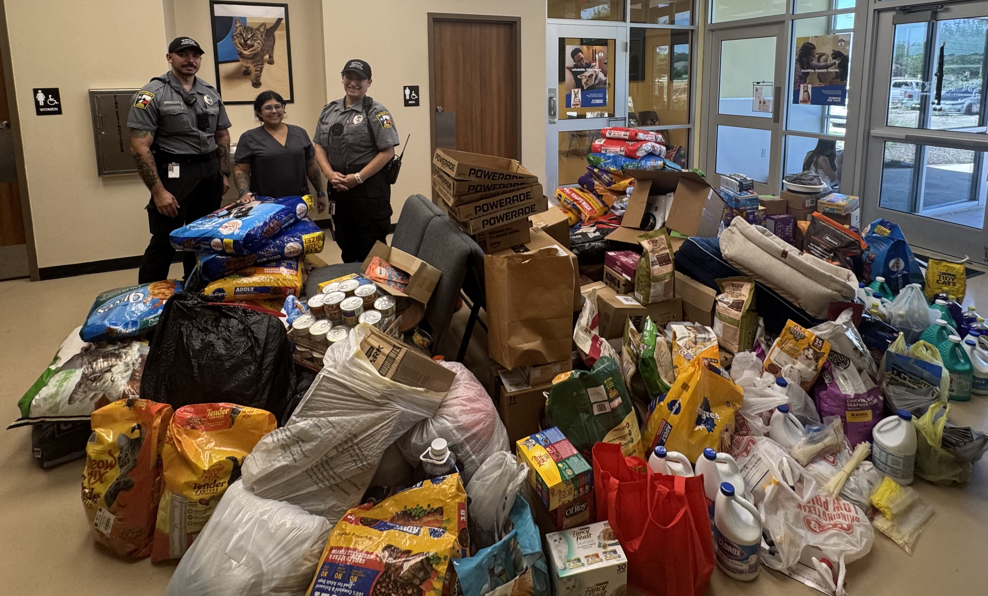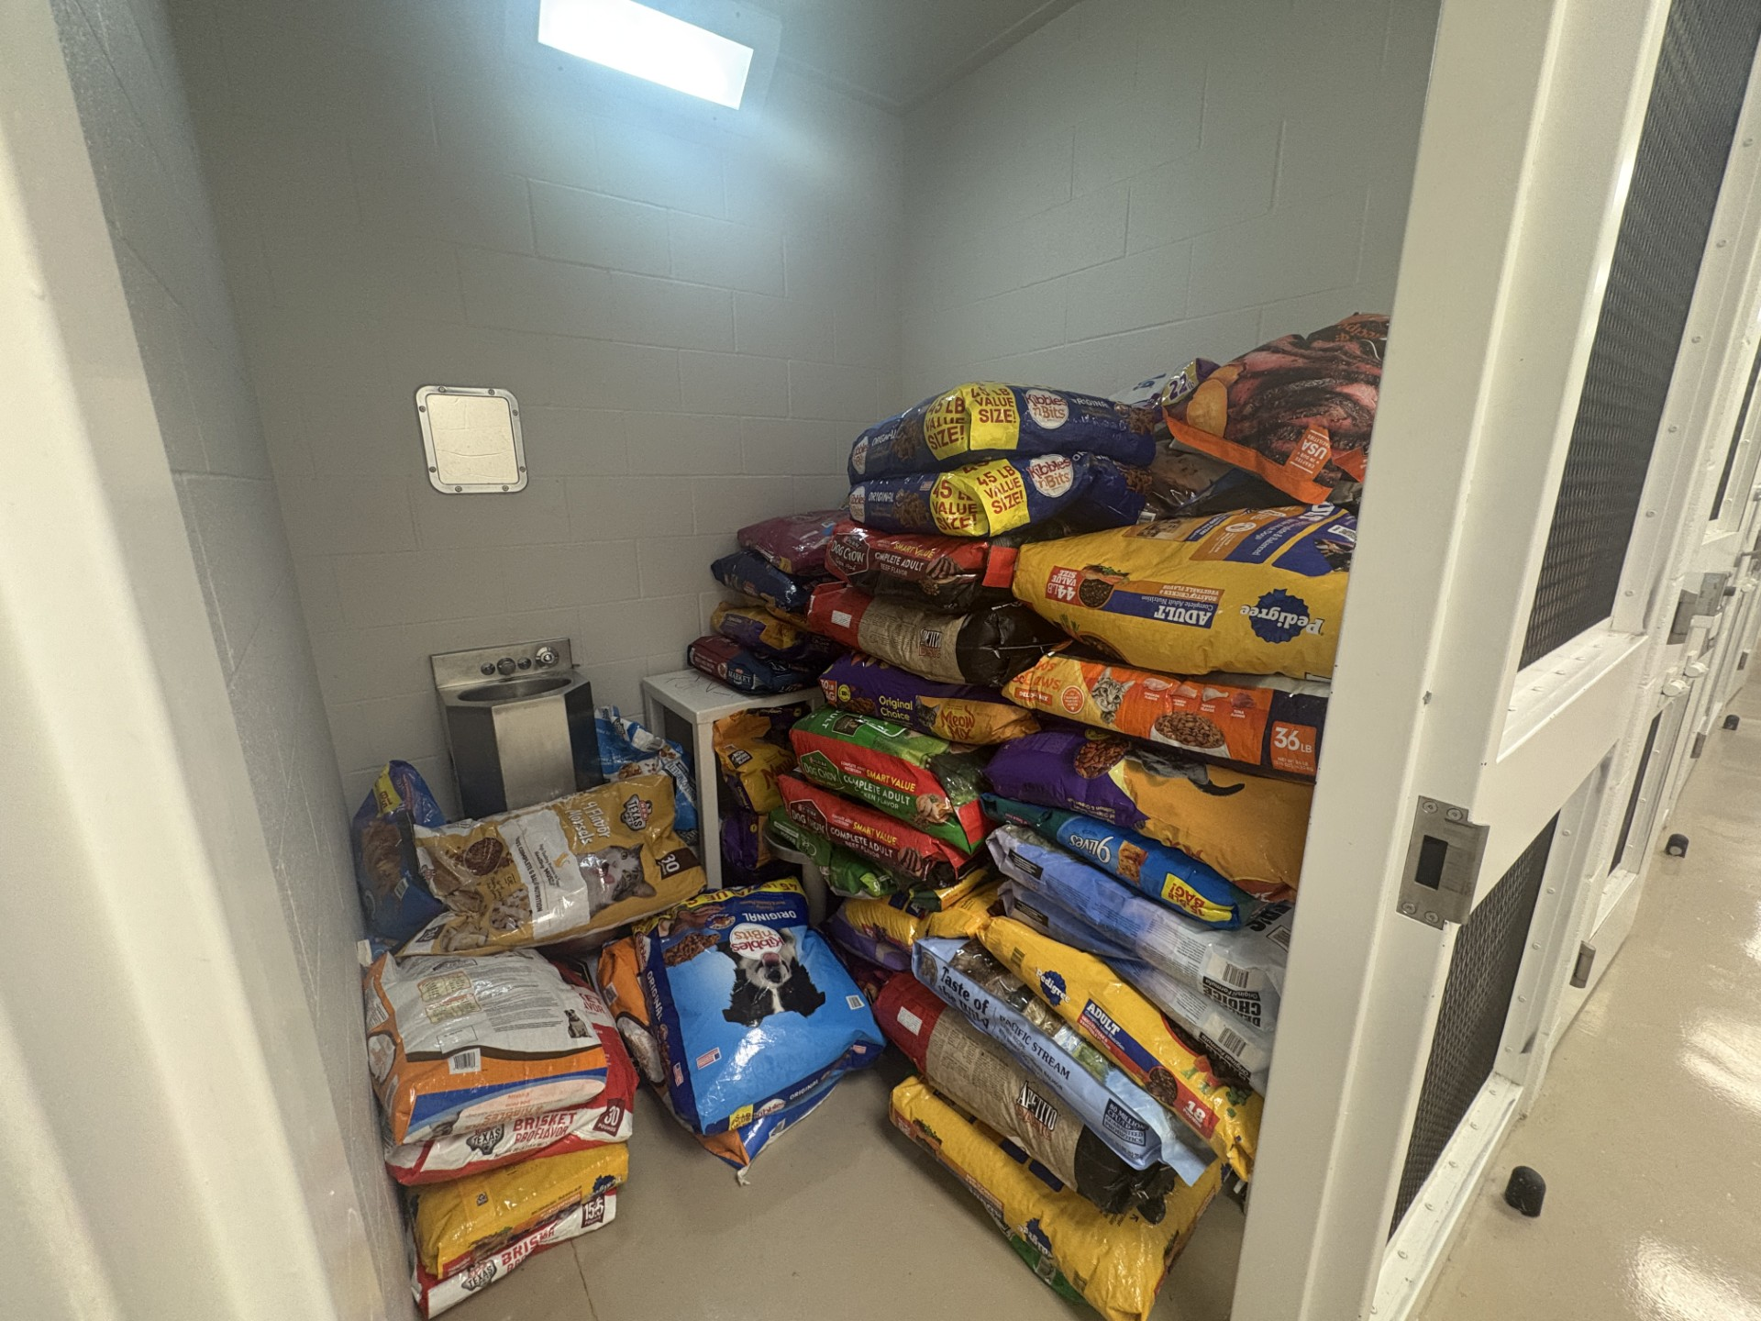
Schertz, TX (7/28/2025) – Currently, we have rescued a total of 64 domestic animals (cats and dogs), with the majority being cats. This sudden influx of animals being attended to by this unfortunate incident has placed a strain on our supplies at our Animal Services Facility. If you are interested in assisting us in mitigating this incident, we are in need of the following supplies:

- Bleach
- Dry cat food
- Wet cat food
- Cat food dishes
- Flea and Tick medication
- Zip ties
- Fabuloso (Apple, Lemon, or Lavender scent)
- Dry dog food
- Newspapers
- Plastic envelopes (5x7)
- Spray bottles

We are also accepting cash donations that will be used to pay for vaccinations and medical bills of the animals seized. All donations can be dropped off at the Schertz Animal Shelter, located at 800 Community Circle. If you have any questions regarding donations, please call our Animal Services at 210-619-1550. This incident continues to be a collaborative and on-going investigation between our Animal Services and Criminal Investigtions Division.
Schertz, TX (July 27, 2025) – On Sunday, July 27, 2025, the Schertz Police Department responded to a report of abandoned animals in need of care at a residence located at 10615 Hillbrook Dr. in Bexar County, Texas. Upon arrival, officers discovered that the home appeared to be abandoned. Inside the residence, numerous dogs and cats were found living in distressing conditions and in need of immediate medical attention. It was clear the animals had been deprived of basic necessities required for survival. The Schertz Animal Control Division was immediately dispatched to the location and took custody of the animals to ensure they received proper treatment, care, and shelter. This incident is part of an active and ongoing investigation, and the Schertz Police Department is working diligently to determine the circumstances surrounding the abandonment. Presently, we have initiated an offense report for Cruelty to Non-livestock Animals which is a Class A Misdemeanor. Further updates will be provided as new information becomes available.
###

